Task on ELB

- Configure Classic Load balancer.

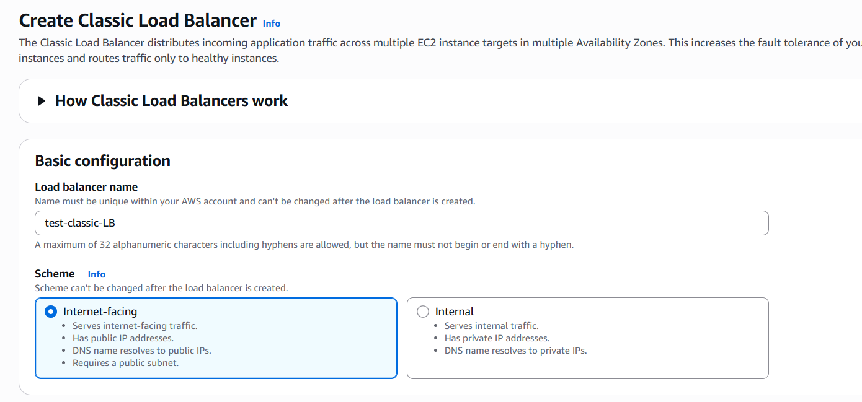
Add vpc and subnets
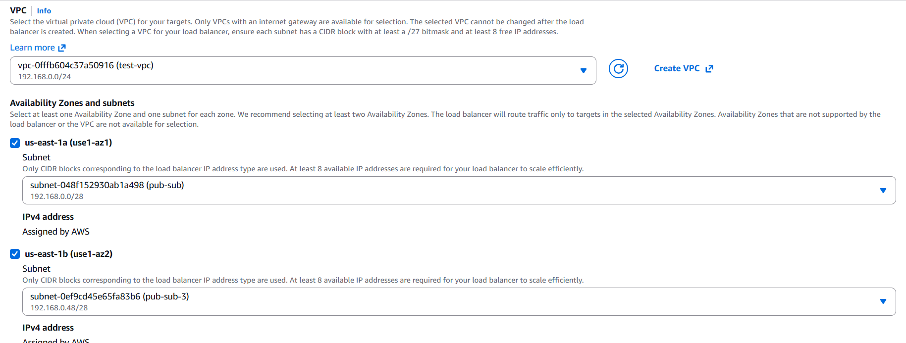
Add instances
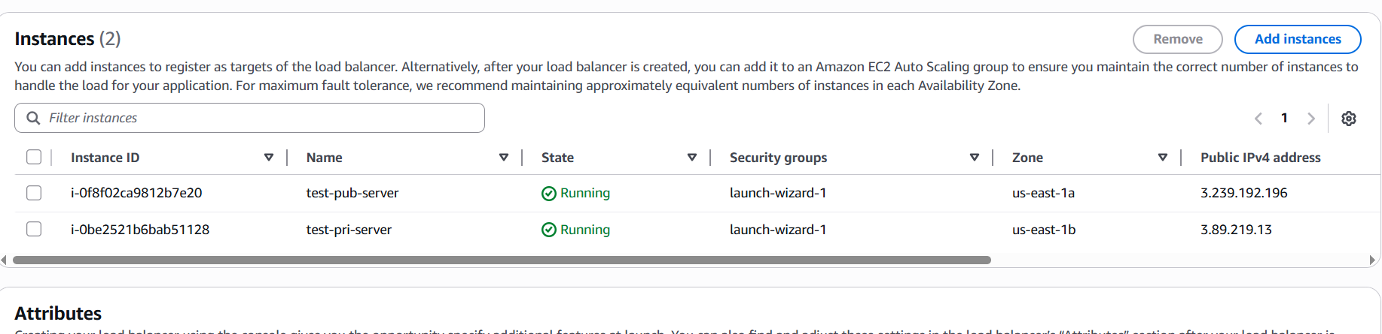
Created classic load balancer
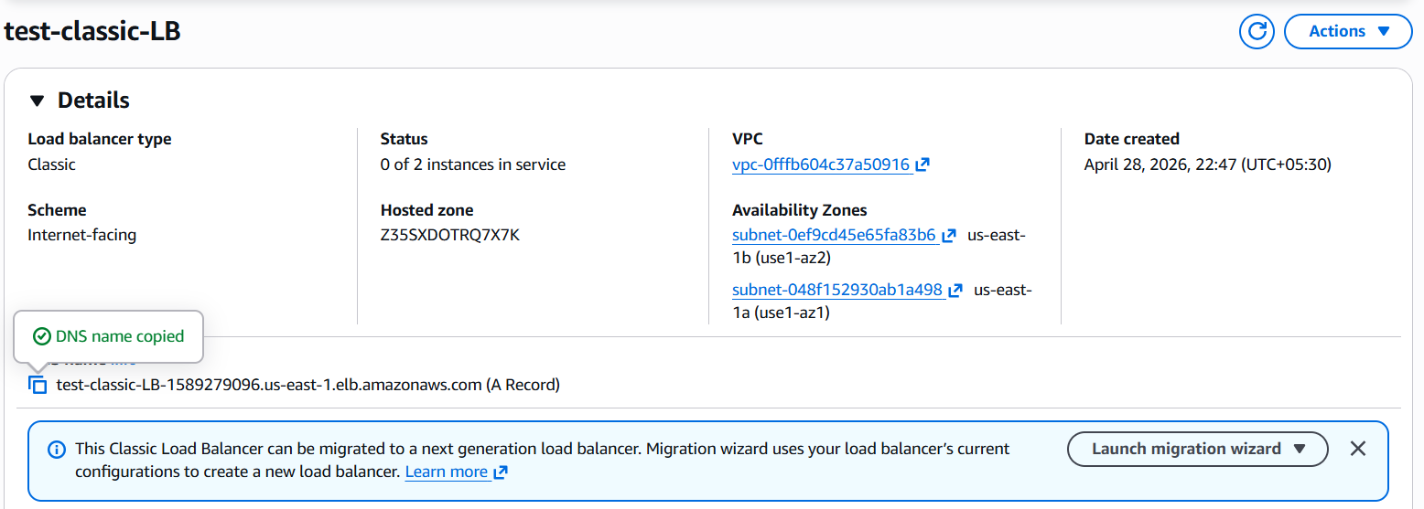

Check with the load balancer dns, we can see the load is distrubuted
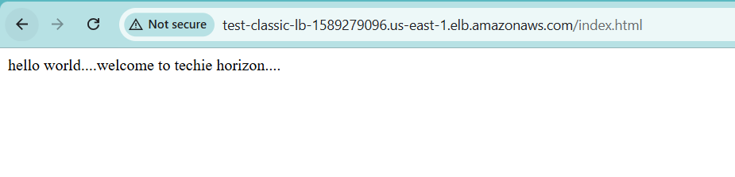

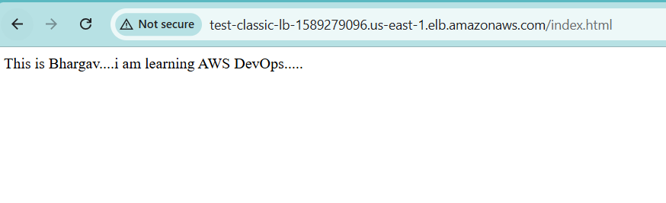

- Configure Application Load balancer.

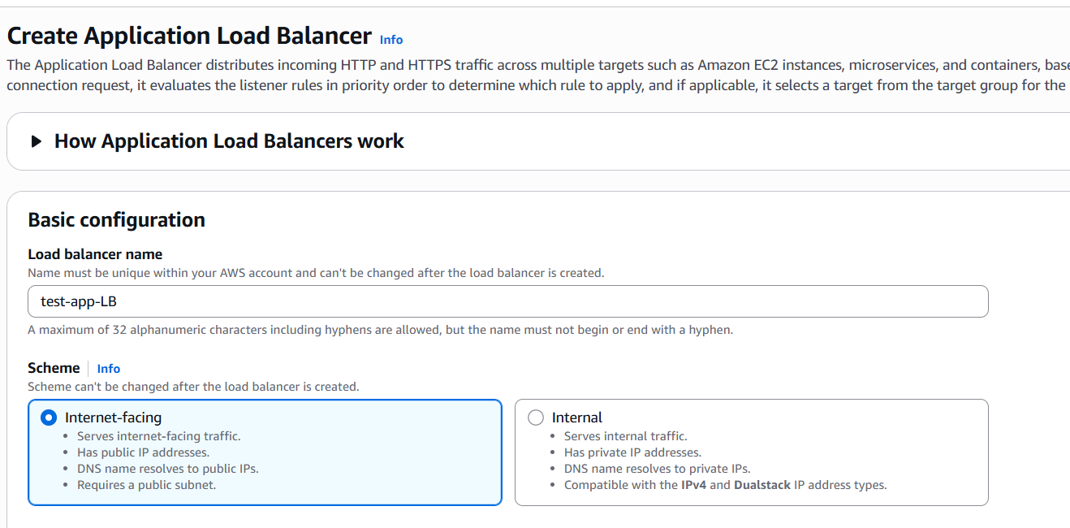

Select your vpc and subnets
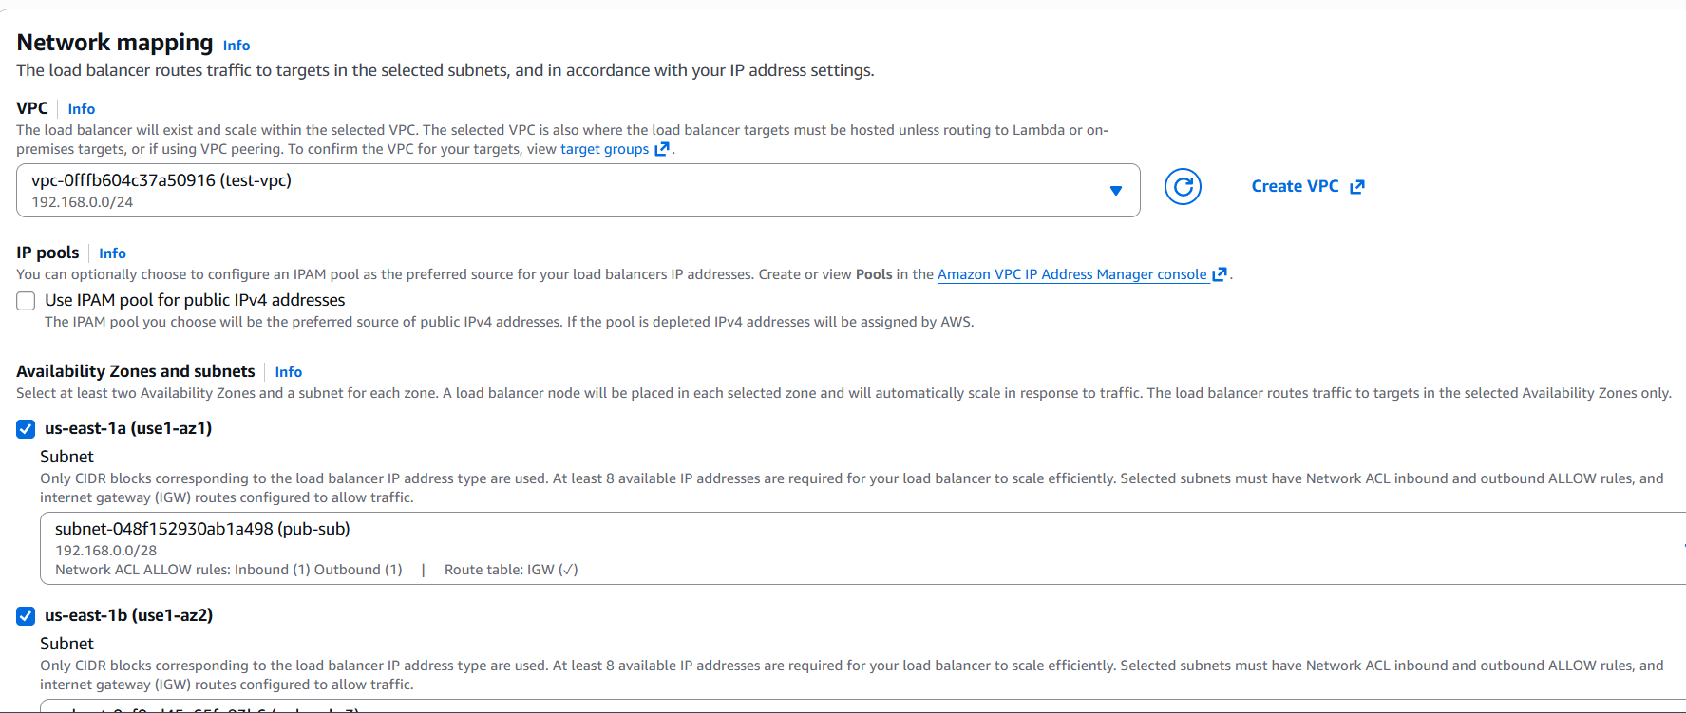

Create target group
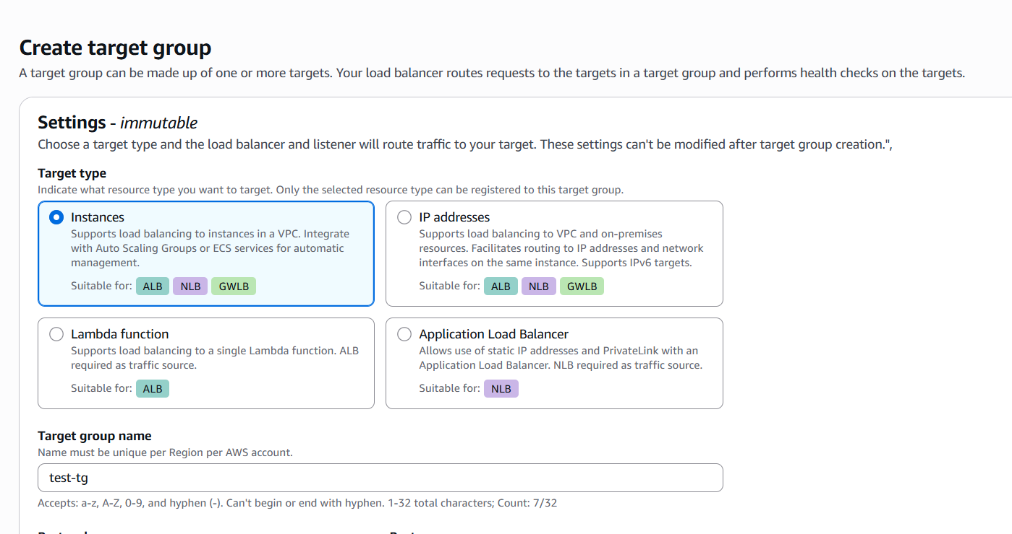
Select your vpc
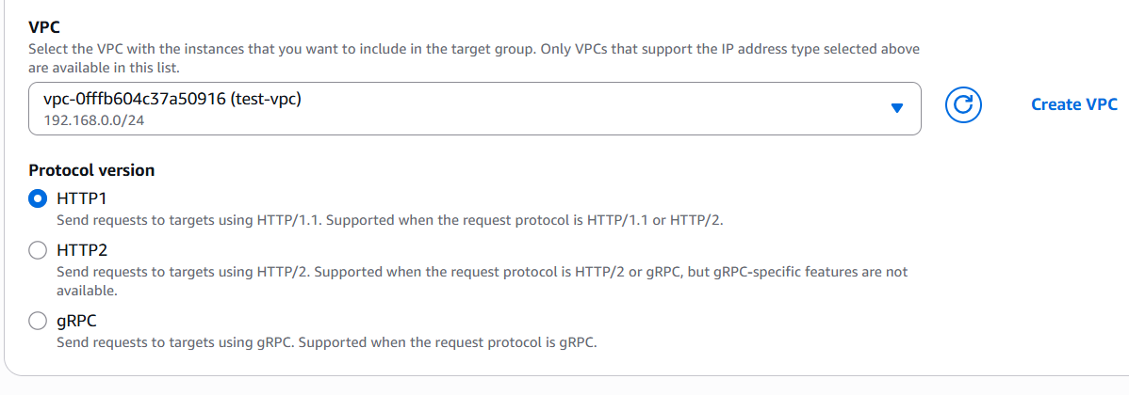

Register your instances
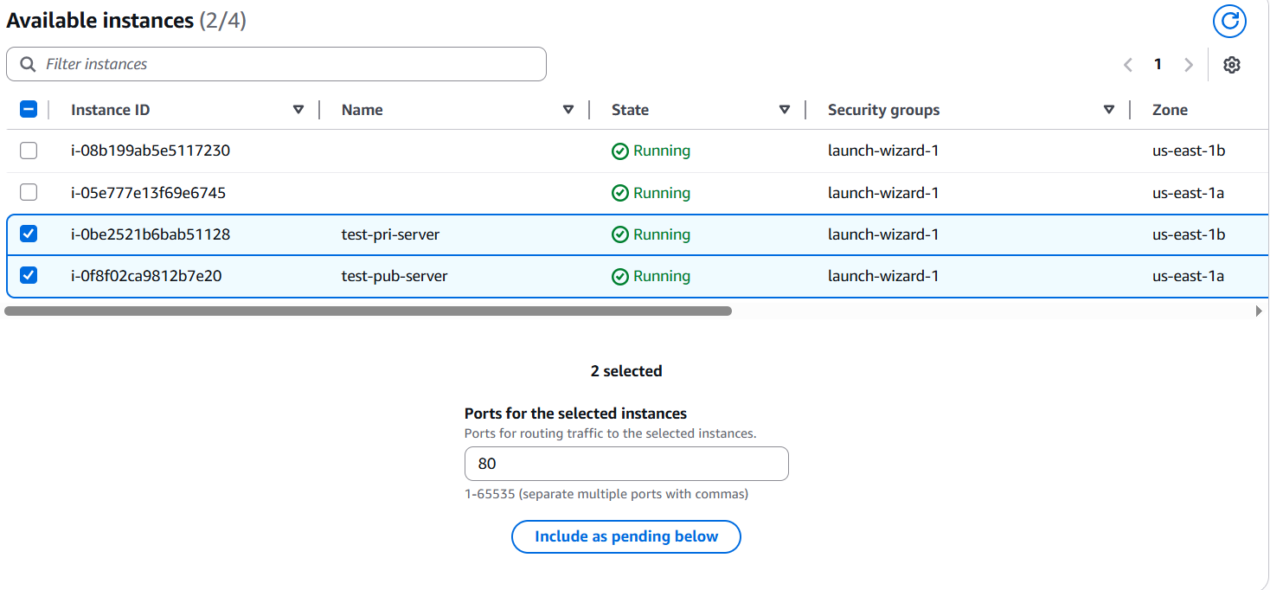
Check weather it is healthy or unhealthy
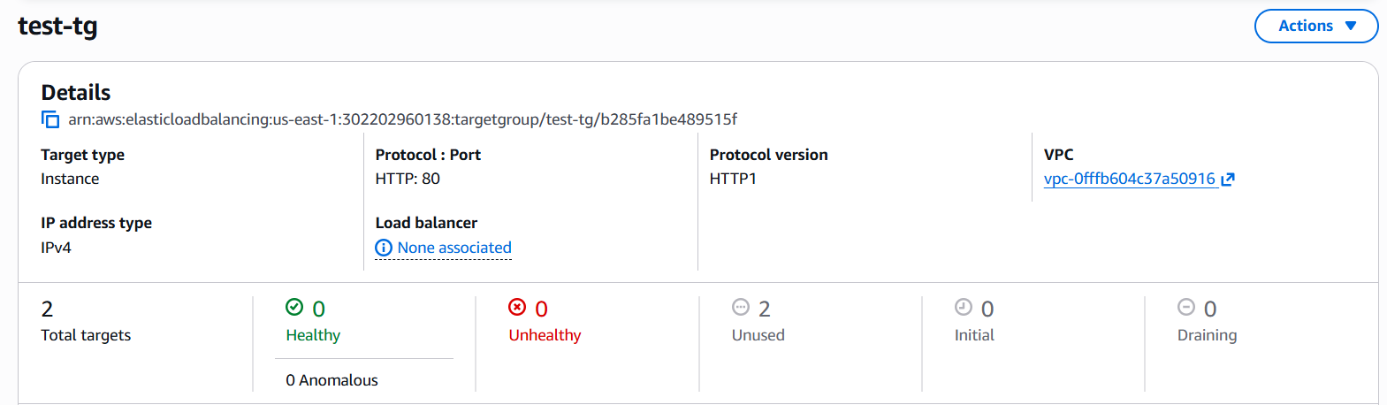
That target group we add to the load balancer
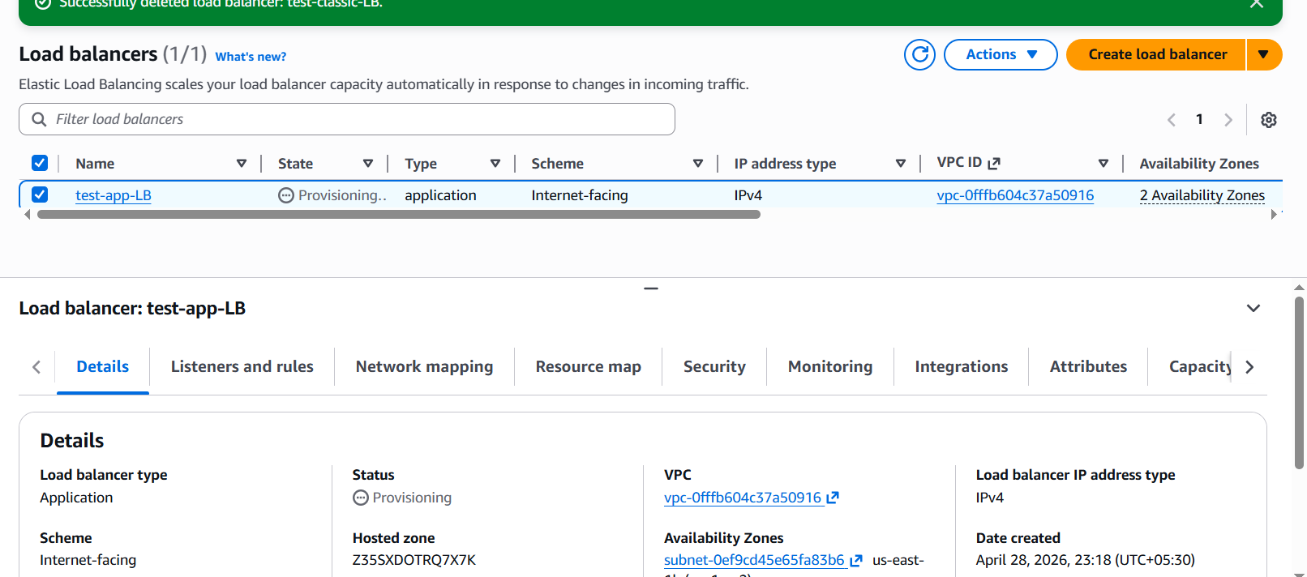
Now we can see it is healthy stage
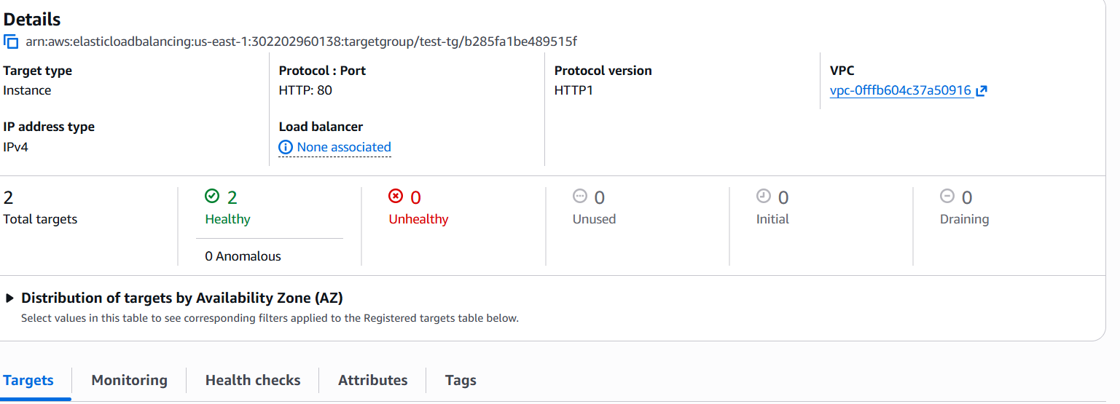
Application load balancer created successfully
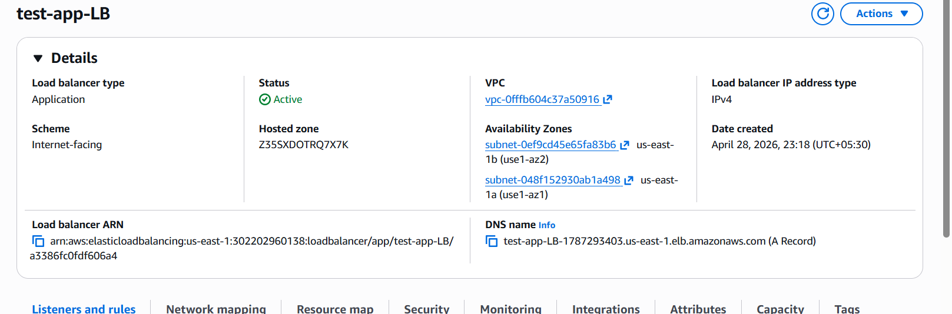

Check with the application load balancer DNS, we can see load is distrubuted
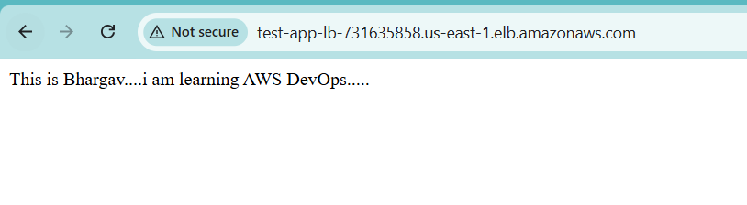

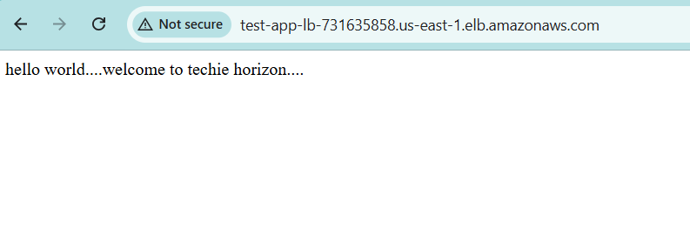

- Configure Network Load balancer.
While creating the network load balancer we have select your vpc and subnets
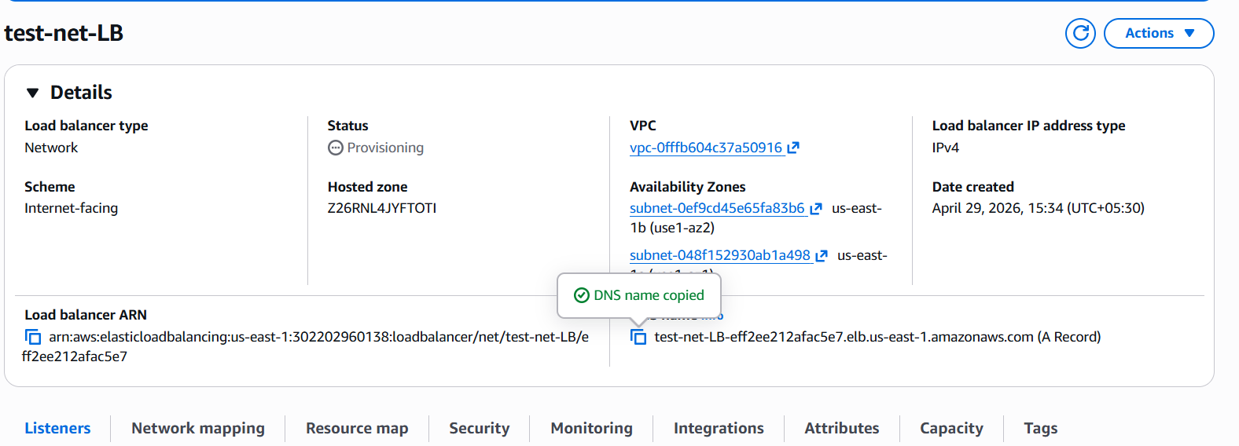

Creating target for network loadbalancer
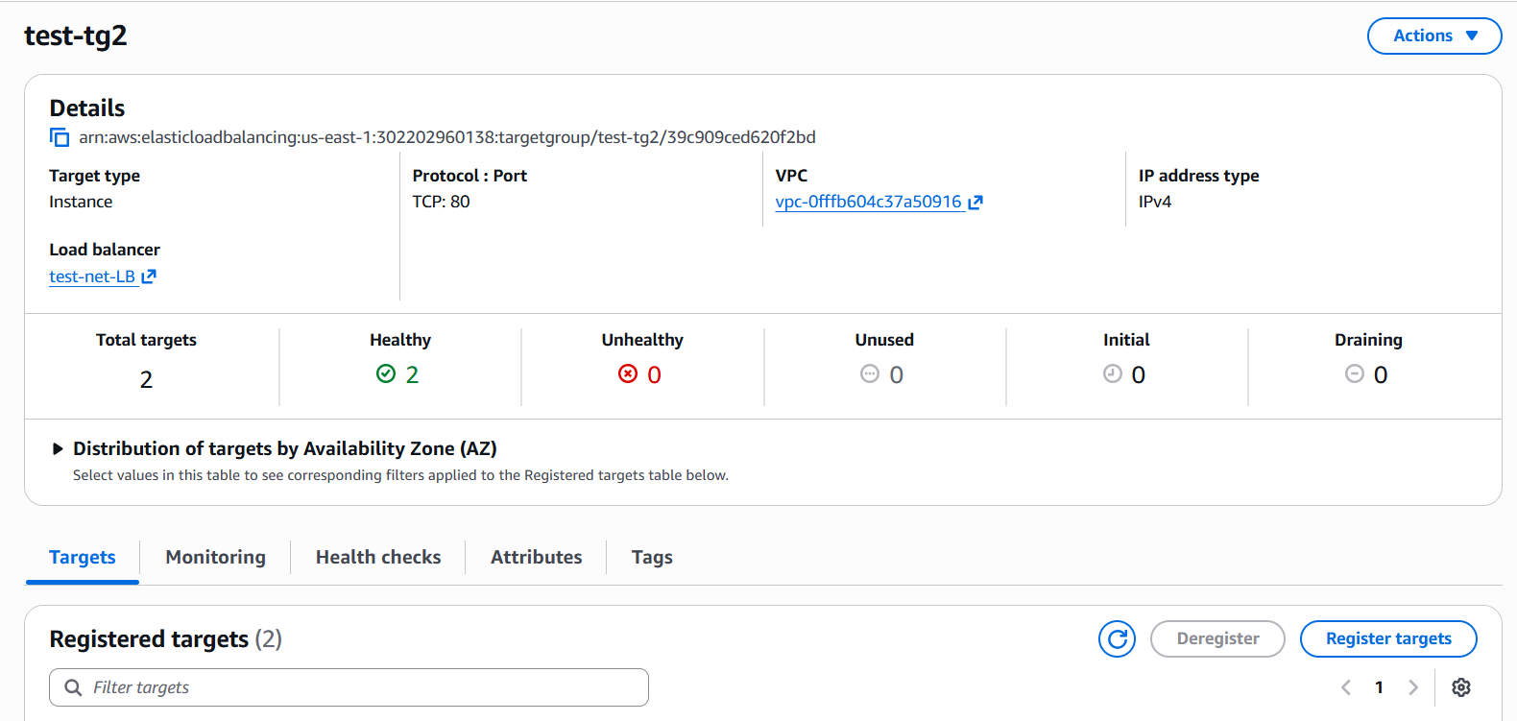

Register your instances
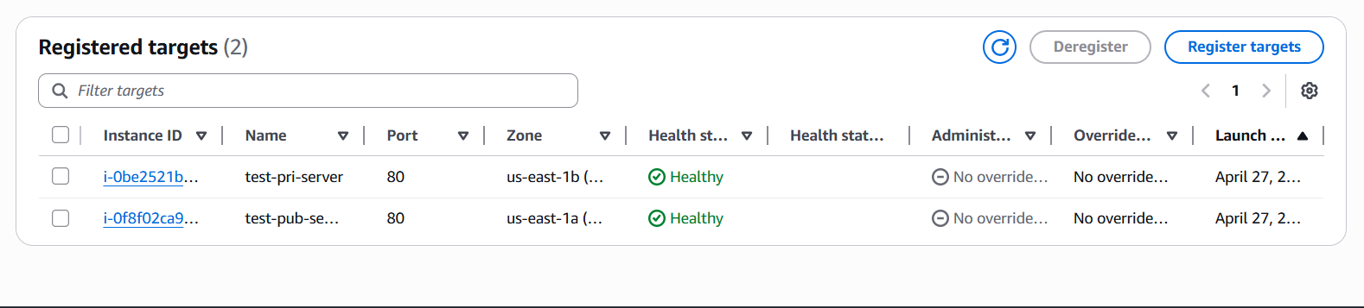
Check with network load balancer DNS
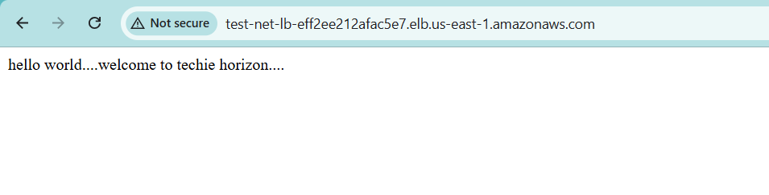

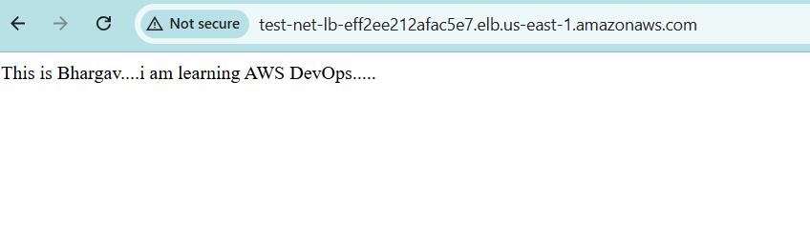

- Attach SSL for application load balancer.

Go to AWS Certificate Manager → Request certificate
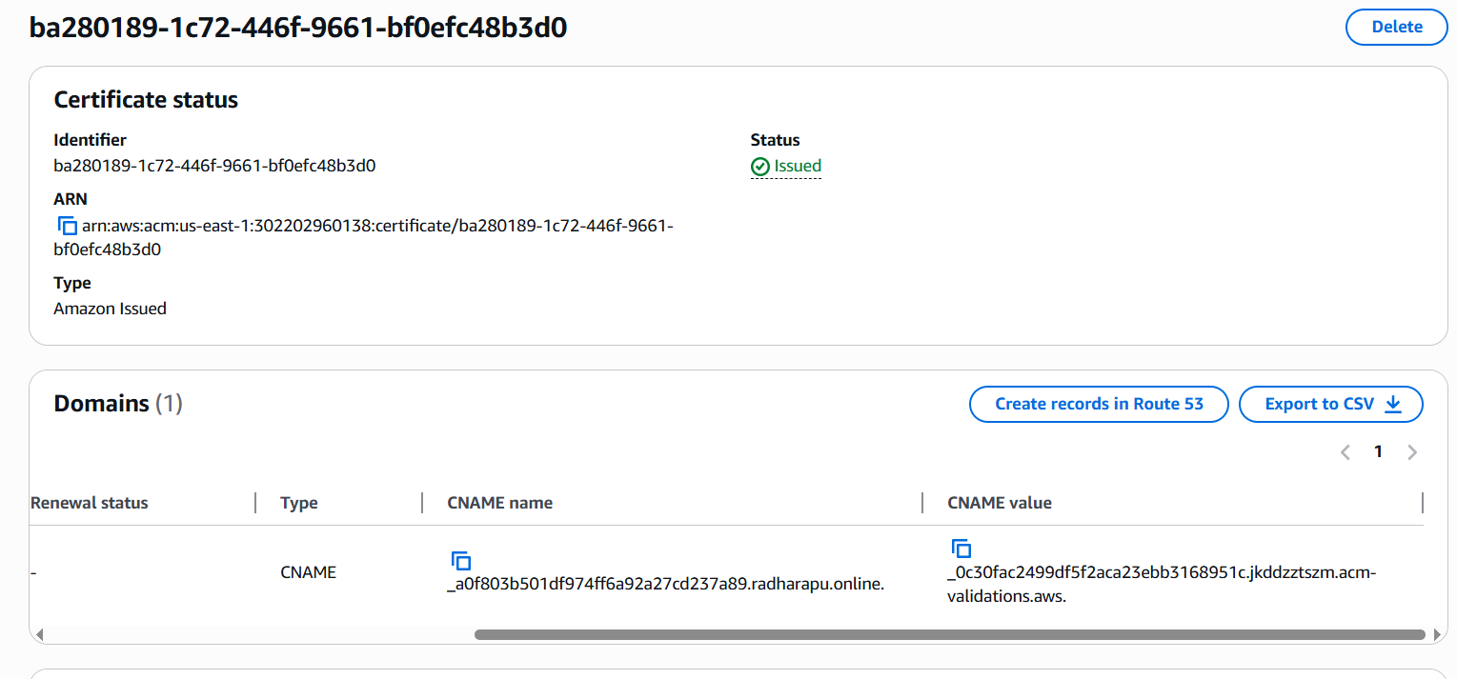
Add HTTPS Listener to Existing ALB
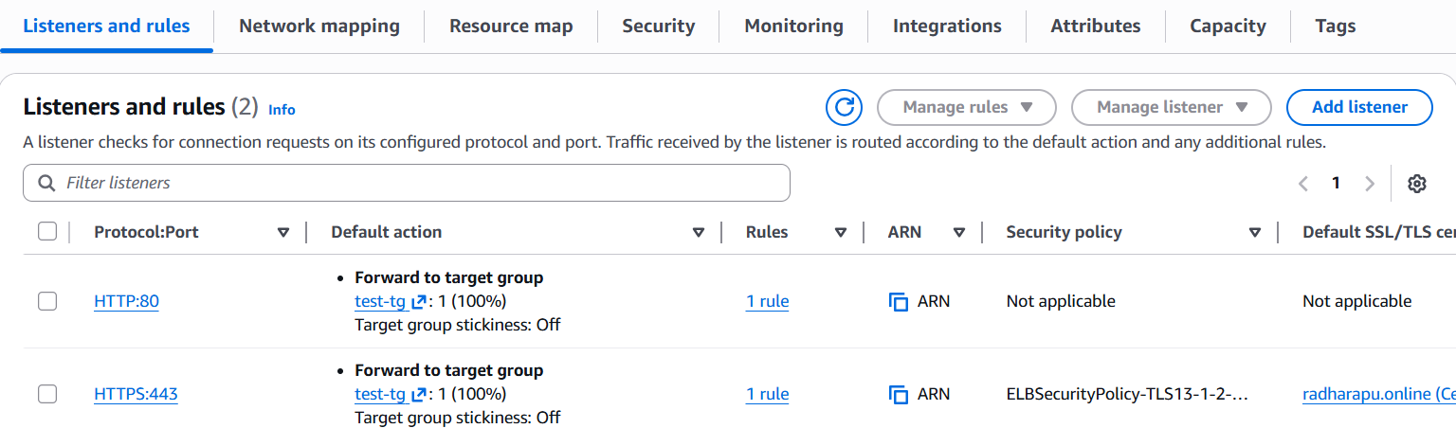

- Map Application load balancer to R53.

Route 53 → Hosted Zones →Create Record
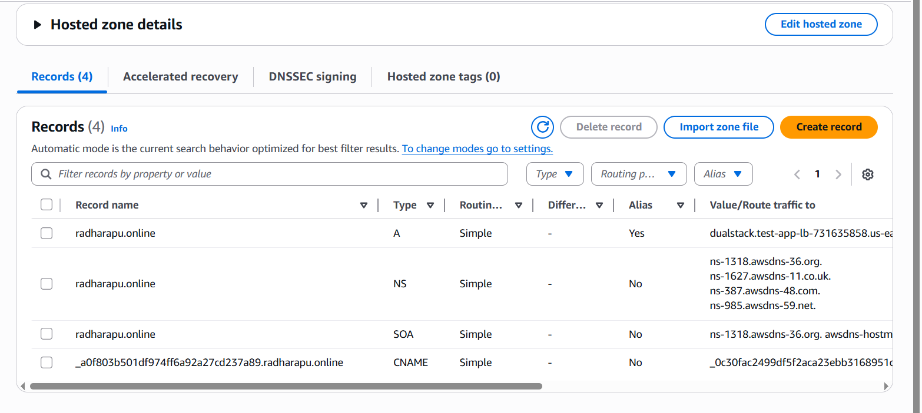
Copy Name servers→goto your godaddy website→change your own NS
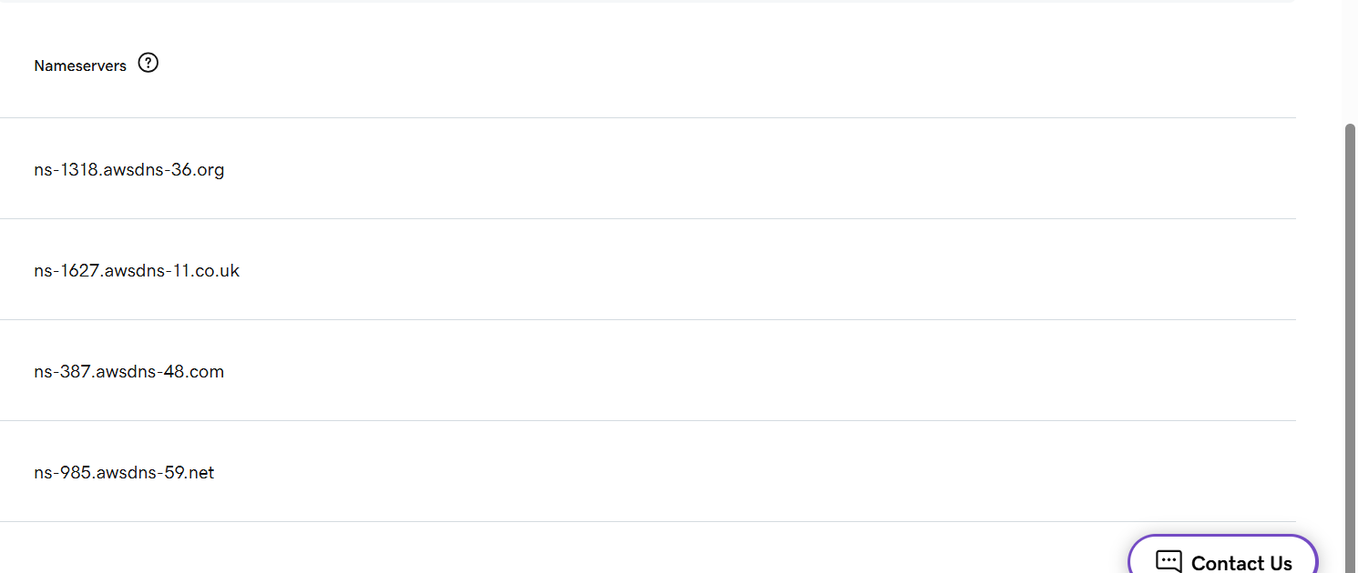

Create record→ add A record→On Alias→choose application load balancer→choose region→choose your Application load balancer–create record

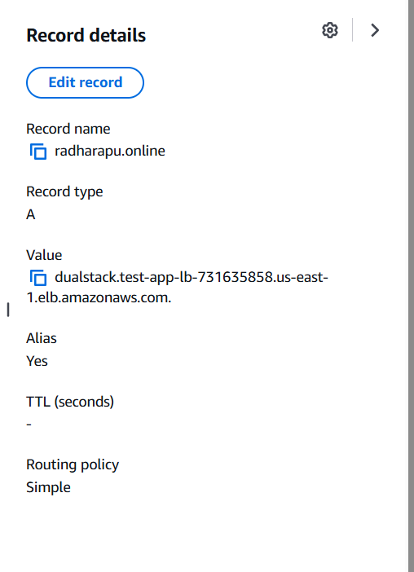

Got to SSL certificate→choose your using certificate for application loadbalancer→click to create cname record in hostedzone (Route53)
We can saw the record in route53 hosted zones
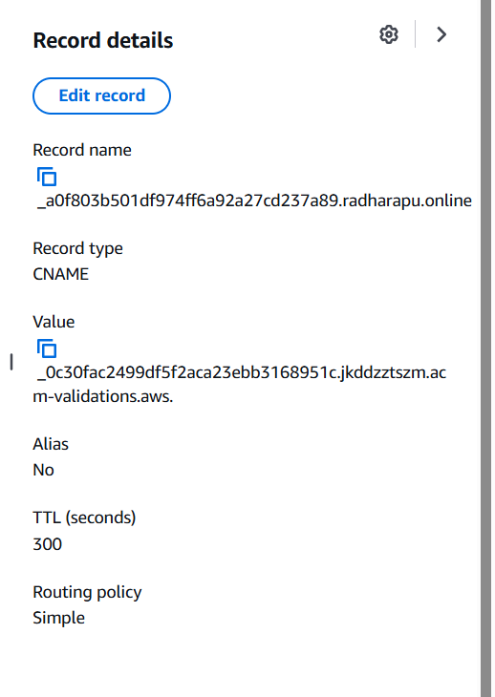

Check in the browser by using your domin add also connected securely.
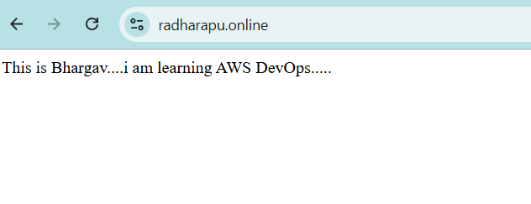

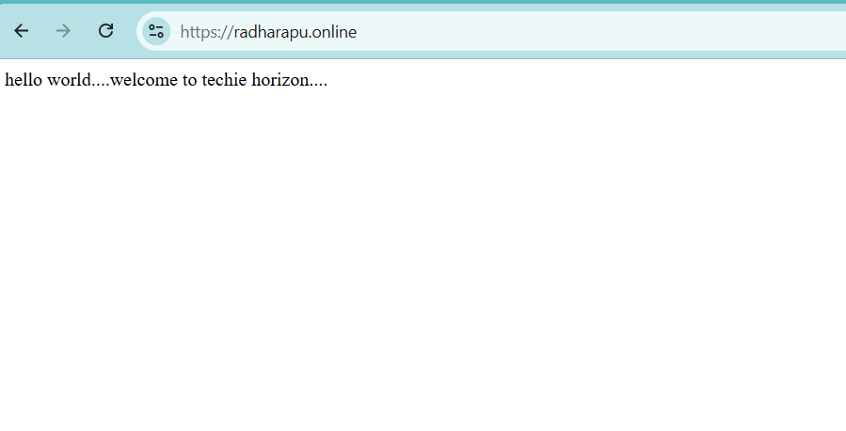

- Push the application load balancer logs to S3.

Create a Bucket
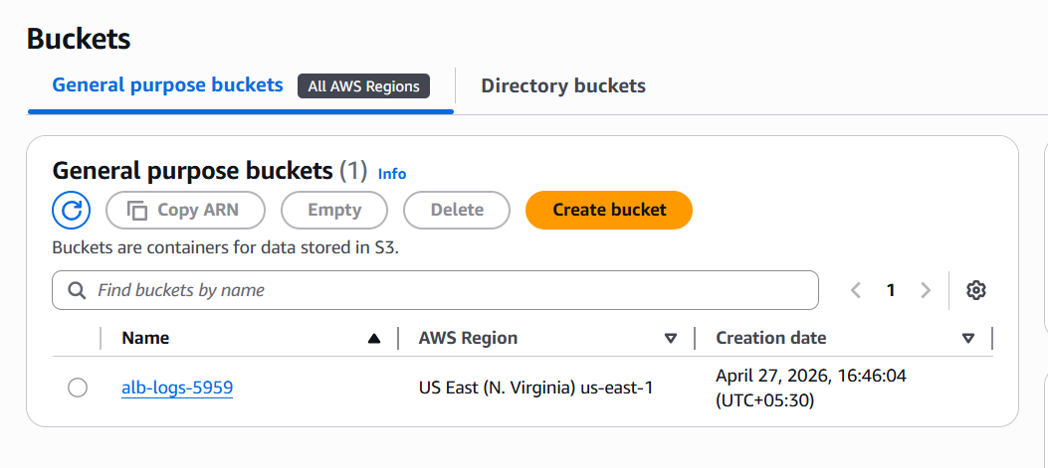
Goto Application loadbalancer→click on Attributes→your able to see last monitoring option→ click on access logs → browse your bucket and selct→ save changes

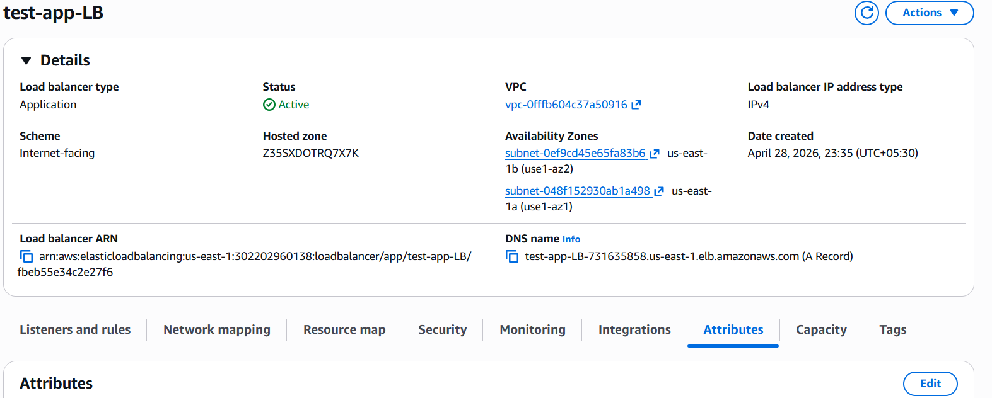

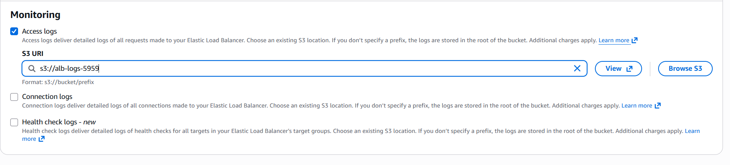
We can see the load balancer logs in S3 bucket

